Additional file 7: Funnel plots of comparisons between D2 blockers and Placebo

DROPOUT DUE TO ANY CAUSE 2
DROPOUT DUE TO ADVERSE EVENTS 3

DROPOUT DUE TO ANY CAUSE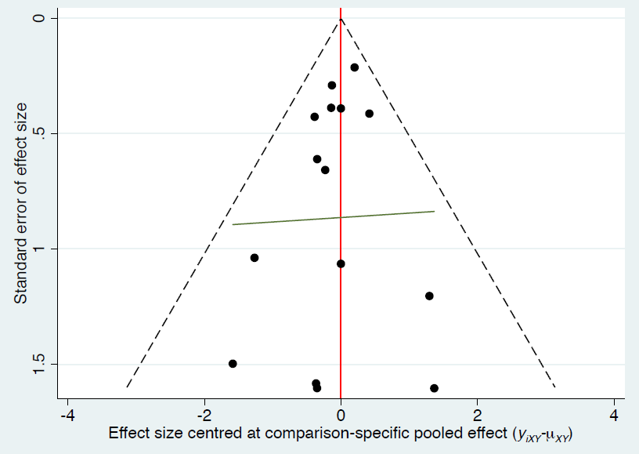

DROPOUT DUE TO ADVERSE EVENTS
